# 

# **E & TC Department**

# **A.Y. 2021-22 Semester-II**

|  |
| --- |
| **Problem statement:** Design a form for student registration using HTML tags.  **Date of Performance: 7**/03/2022.  **Theme**: Student Registration Form Webpage. |

# **ET-A Batch A1**

# **GROUP 6**

|  |  |  |
| --- | --- | --- |
| **Gr No** | **Roll No:** | **Name** |
| 11910109 | 3 | Anant Abhyankar |
| 12020074 | 16 | Ali Aslam |
| 11910008 | 25 | Ankush Chadgal |

1. **Home Page.**

<!DOCTYPE html>

<html lang="en">

<head>

<link rel="icon" href="logo.png">

<meta charset="UTF-8">

<meta http-equiv="X-UA-Compatible" content="IE=edge">

<meta name="viewport" content="width=device-width, initial-scale=1.0">

<title>WT_Lab_2_Group_6</title>

</head>

<body>

<table id="header" border="0" width="100%" cellpadding="0" cellspacing="0" bgcolor="#1979a9">

<tr>

<td>

<table border="0" width="85%" cellpadding="10" cellspacing="0" align="center">

<tr>

<td>

<font face="Aharoni" color="#FFFF00" size="6">

<marquee behavior="" direction="left" align="">Student Registration Form Started

</marquee>

</font>

</td>

</td>

<td width="5%">

&nbsp;

</td>

</tr>

</table>

<table id="header" border="0" width="100%" cellpadding="0" cellspacing="0" bgcolor="#sasas">

<tr>

<td>

<table border="0" width="100%" cellpadding="10" cellspacing="0" align="center">

<tr>

<td>

<font face="Aharoni" color="#9999" size="5">

</td>

<td width="18%">

&nbsp;

</td>

<td>

<a href="#">

<font face="Aharoni" color="#FFFFFF" size="4">Home</font>

</color>

</a>&nbsp;&nbsp;&nbsp;&nbsp;&nbsp;&nbsp;&nbsp;&nbsp;&nbsp;&nbsp;&nbsp;&nbsp;&nbsp;&nbsp;&nbsp;&nbsp;&nbsp;

</a>

<a href="#">

<font face="Aharoni" color="#FFFFFF" size="4">About Us</font>

</color>

</a>&nbsp;&nbsp;&nbsp;&nbsp;&nbsp;&nbsp;&nbsp;&nbsp;&nbsp;&nbsp;&nbsp;&nbsp;&nbsp;&nbsp;&nbsp;&nbsp;&nbsp;

<a href="#">

<font face="Aharoni" color="#FFFFFF" size="4">Admissions</font>

</color>

</a>&nbsp;&nbsp;&nbsp;&nbsp;&nbsp;&nbsp;&nbsp;&nbsp;&nbsp;&nbsp;&nbsp;&nbsp;&nbsp;&nbsp;&nbsp;&nbsp;&nbsp;

<a href="Departments.html">

<font face="Aharoni" color="#FFFFFF" size="4">Departments</font>

</color>

</a>&nbsp;&nbsp;&nbsp;&nbsp;&nbsp;&nbsp;&nbsp;&nbsp;&nbsp;&nbsp;&nbsp;&nbsp;&nbsp;&nbsp;&nbsp;&nbsp;&nbsp;

<a href="Login.html">

<font face="Aharoni" color="#FFFFFF" size="4">Login/Sign</font>

</color>

</a>

</td>

</tr>

</tr>

</table>

</table>

<!-- End Header

Start Header -->

<table id="home" border="0" width="100%" cellpadding="0" cellspacing="0" bgcolor="#292929">

<tr>

<td>

<table border="0" width="85%" cellpadding="" cellspacing="0" align="center">

<tr>

<img src="https://www.getadmissioninfo.com/uploads/topics/vishwakarma-institute-of-technology-vit-pune.jpg" alt="" width="100%" height="">

</td>

</tr>

</table>

<!--End Home-->

<!--student registration form-->

<table id="header" border="0" width="100%" cellpadding="0" cellspacing="0" bgcolor="red">

<tr>

<td>

<table border="0" width="85%" cellpadding="10" cellspacing="0" align="center">

<tr>

<td>

<center>

<font face="Aharoni" color="#FFFF00" size="6">

<marquee behavior="alternate" direction="">Student Registration Form</marquee>

</center>

</font>

</td>

</td>

<!--student registration form-->

<table id="header" border="0" width="100%" cellpadding="10" cellspacing="0" bgcolor="#04124f">

<tr>

<td>

<table border="0" width="85%" cellpadding="10" cellspacing="0" align="center">

<tr>

<td>

<font face="Aharoni" color="#FFFF00" size="">

<form action="Back.html">

<center>

<table style="border: 5px;">

<tr>

<td>

STUDENT'S FULL NAME :

</td>

<td>

<input type="text" placeholder="your full name" name="full name" size="15" maxlength="15">(maximum 15 characters a-z and A-Z)

</td>

</tr>

<tr>

<td>

FATHER NAME :

</td>

<td>

<input type="text" placeholder="your father name" name="father name" size="15" maxlength="15">(max 15 characters a-z and A-Z)

</td>

</tr>

<tr>

<td>

MOTHER NAME :

</td>

<td>

<input type="text" placeholder="your mother name" name="MOTHER NAME" size="15" maxlength="15">(maximum 15 characters a-z and A-Z)

</td>

</tr>

<tr>

<td> DATE OF BIRTH :</td>

<td> <select name="DATE">

<option value="DATE">DATE</option>

<option value="DATE">1</option>

<option value="DATE">2</option>

<option value="DATE">3</option>

<option value="DATE">4</option>

<option value="DATE">5</option>

<option value="DATE">6</option>

<option value="DATE">7</option>

<option value="DATE">8</option>

<option value="DATE">9</option>

<option value="DATE">10</option>

<option value="DATE">11</option>

<option value="DATE">12</option>

<option value="DATE">13</option>

<option value="DATE">14</option>

<option value="DATE">15</option>

<option value="DATE">16</option>

<option value="DATE">17</option>

<option value="DATE">18</option>

<option value="DATE">19</option>

<option value="DATE">20</option>

<option value="DATE">21</option>

<option value="DATE">22</option>

<option value="DATE">23</option>

<option value="DATE">24</option>

<option value="DATE">25</option>

<option value="DATE">26</option>

<option value="DATE">27</option>

<option value="DATE">28</option>

<option value="DATE">29</option>

<option value="DATE">30</option>

<option value="DATE">31</option>

</select>

<select name="MONTH">

<option value="MONTH">MONTH</option>

<option value="MONTH">January</option>

<option value="MONTH">February</option>

<option value="MONTH">March</option>

<option value="MONTH">April</option>

<option value="MONTH">May</option>

<option value="MONTH">June</option>

<option value="MONTH">July</option>

<option value="MONTH">August</option>

<option value="MONTH">september</option>

<option value="MONTH">October</option>

<option value="MONTH">November</option>

<option value="MONTH">December</option>

</select>

<select name="YEAR">

<option value="YEAR">YEAR</option>

<option value="YEAR">1975</option>

<option value="YEAR">1976</option>

<option value="YEAR">1977</option>

<option value="YEAR">1978</option>

<option value="YEAR">1979</option>

<option value="YEAR">1980</option>

<option value="YEAR">1981</option>

<option value="YEAR">1982</option>

<option value="YEAR">1983</option>

<option value="YEAR">1984</option>

<option value="YEAR">1985</option>

<option value="YEAR">1986</option>

<option value="YEAR">1987</option>

<option value="YEAR">1988</option>

<option value="YEAR">1989</option>

<option value="YEAR">1990</option>

<option value="YEAR">1991</option>

<option value="YEAR">1992</option>

<option value="YEAR">1993</option>

<option value="YEAR">1994</option>

<option value="YEAR">1995</option>

<option value="YEAR">1996</option>

<option value="YEAR">1997</option>

<option value="YEAR">1998</option>

<option value="YEAR">1999</option>

<option value="YEAR">2000</option>

<option value="YEAR">2001</option>

<option value="YEAR">2002</option>

<option value="YEAR">2003</option>

<option value="YEAR">2004</option>

<option value="YEAR">2005</option>

</select>

</td>

</tr>

<tr>

<td>

MOBILE NUMBER :

</td>

<td>

<input type="number" placeholder="your mobile number" name="Mobile number" size="11" maxlength="11"> (11 digit number)

</td>

</tr>

<tr>

<td>

PARENTS NUMBER :

</td>

<td>

<input type="number" placeholder="your parents mobile number" name="Mobile number" size="11" maxlength="11"> (11 digit number)

</td>

</tr>

<tr>

<td>

STUDENT EMAIL ID :

</td>

<td>

<input type="123@gmail.com" placeholder="123@gmail.com" name="STUDENT EMAIL" size="15" maxlength="15">

</td>

</tr>

<tr>

<td>

PARENTS EMAIL ID :

</td>

<td>

<input type="123@gmail.com" placeholder="123@gmail.com" name="STUDENT EMAIL" size="15" maxlength="15">

</td>

</tr>

<tr>

<td>

GENDER

</td>

<td>

MALE: <input type="radio" name="Gender"> FEMALE: <input type="radio" name="Gender"> OTHERS: <input type="radio" name="Gender">

</td>

</tr>

<tr>

<td>

ADDRESS :

</td>

<td>

<textarea name="Address" cols="30" rows="5"></textarea>

</td>

</tr>

<tr>

<td>

CITY :

</td>

<td>

<input type="text" placeholder="enter city name" name="CITY" size="15" maxlength="15">(max 15 characters a-z and A-Z)

</td>

</tr>

<tr>

<td>

POSTAL CODE :

</td>

<td>

<input type="number" placeholder="enter postal code" name="postal code" size="15" maxlength="5">(max 5 characters a-z and A-Z)

</td>

</tr>

<tr>

<td>

COUNTRY :

</td>

<td>

<input type="text" placeholder="enter country name" name="country" size="30" maxlength="30">

</td>

<tr>

<td>

HOBBIES :

</td>

<td>

Drawing:<input type="Checkbox" value="Drawing" name="Hobbies"> Singing:

<input type="Checkbox" value="Singing" name="Hobbies"> Cricket:

<input type="Checkbox" value="Cricket" name="Hobbies"> Dancing:

<input type="Checkbox" value="Dancing" name="Hobbies"> <br> Others:

<input type="Checkbox" value="Others" name="Hobbies"><input type="text" placeholder="your hobbies" name="Others" size="30" maxlength="15">(maximum 30 characters a-z)

</td>

</tr>

<tr>

<td> QUALIFICATIONS </td>

<td>

<table>

<tr>

<th>S.no</th>

<th>Examinations</th>

<th>Board</th>

<th>percentage</th>

<th>year of passing</th>

</tr>

<tr>

<td>1</td>

<td>Class X </td>

<td> <input type="text"></td>

<td> <input type="number"></td>

<td> <input type="number"></td>

</tr>

<tr>

<td>2</td>

<td>Class XII</td>

<td> <input type="text"></td>

<td> <input type="number"></td>

<td> <input type="number"></td>

</tr>

<tr>

<td>3</td>

<td>Graduation</td>

<td> <input type="text"></td>

<td> <input type="number"></td>

<td> <input type="number"></td>

</tr>

<tr>

<td>4</td>

<td>Masters</td>

<td> <input type="text"></td>

<td> <input type="number"></td>

<td> <input type="number"></td>

</tr>

</table>

</td>

</tr>

<tr>

<td>

COURSES APPLIED FOR:

</td>

<td>

B.CA: <input type="radio" name="COURSES APPLIED FOR"> B.COM: <input type="radio" name="COURSES APPLIED FOR"> B.SC: <input type="radio" name="COURSES APPLIED FOR"> B.A:

<input type="radio" name="COURSES APPLIED FOR"> B.TECH

<label>

Branch :

</label>

<select>

<option value="Branch" >Branch/option>

<option value="ENTC">ENTC</option>

<option value="ME">ME</option>

<option value="CS">CS</option>

<option value="IT">IT</option>

<option value="Chemical">Chemical</option>

<option value="Instrumentation">Instrumentation</option>

</select>

</td>

</tr>

<tr>

<td>

ENTER PASSWORD :

</td>

<td>

<input type="password" placeholder="passwd" name="PASSWORD" size="11" maxlength="11">

</td>

</tr>

<tr>

<td>

RETYPE PASSWORD :

</td>

<td>

<input type="password" placeholder="passwd" name="PASSWORD" size="11" maxlength="11">

</td>

</tr>

<tr>

<td>

<input type="button" class="button_active" value="Submit" onclick="location.href='sucess.html'" ;>

</td>

<td>

<button type="reset">Reset </button>

</td>

</tr>

</div>

</table>

</form>

</div>

</center>

</font>

</td>

</tr>

</table>

<!--Start About-->

<table id="about" border="0" width="100%" cellpadding="0" cellspacing="0" bgcolor="#292929">

<tr>

<td>

<table border="0" width="85%" cellpadding="15" cellspacing="0" align="center">

<tr>

<td height="180" align="center" valign="middle" colspan="2">

<font face="arial" color="#f3971b" size="6">

About

</font>

<hr width="70" color="#f3971b">

<br>

<font face="Aharoni" color="#f3971b1" size="4">

<a href="https://www.youtube.com/" target="_blank" rel="noopener noreferrer">

<a style="color: rgb(255, 217, 0);"> YouTube </a></a>&nbsp;&nbsp;|&nbsp;&nbsp;

<a target="_blank" rel="noopener noreferrer">

<a style="color: rgb(255, 217, 0);">LinkedIn </a></a>&nbsp;&nbsp;|&nbsp;&nbsp;

<a target="_blank" rel="noopener noreferrer"> <a style="color: rgb(255, 217, 0);">Instagram </a></a>

</font>

</td>

</tr>

<!-- about End-->

<!-- Footer start-->

<table id="header" border="0" width="100%" cellpadding="0" cellspacing="0" bgcolor="#35325">

<tr>

<td>

<table border="0" width="85%" cellpadding="0" cellspacing="0" align="center">

<tr>

<td>

<font face="Aharoni" color="#9999" size="4">

FAQ

</font>

</td>

<td width="20%">

&nbsp;

</td>

<td>

<a href="#">

<font face="Aharoni" color="#FFFFFF" size="4">Contact Us</font>

</color>

</a>&nbsp;&nbsp;&nbsp;&nbsp;&nbsp;&nbsp;&nbsp;&nbsp;&nbsp;&nbsp;&nbsp;

</a>

<a href="#">

<font face="Aharoni" color="#FFFFFF" size="4">Quick Link</font>

</color>

</a>&nbsp;&nbsp;&nbsp;&nbsp;&nbsp;&nbsp;&nbsp;&nbsp;&nbsp;&nbsp;&nbsp;&nbsp;

<a href="#">

<font face="Aharoni" color="#FFFFFF" size="4">Sister Institites </font>

</color>

</a>&nbsp;&nbsp;&nbsp;&nbsp;&nbsp;&nbsp;&nbsp;&nbsp;&nbsp;&nbsp;&nbsp;&nbsp;

<a href="#">

<font face="Aharoni" color="#FFFFFF" size="5">&copy; 2022</font>

</color>

</a>&nbsp;&nbsp;&nbsp;&nbsp;&nbsp;&nbsp;&nbsp;&nbsp;&nbsp;&nbsp;

</td>

</tr>

</tr>

</table>

</table>

<!-- Footer end-->

</body>

</html>

1. **Login Webpage:**

<!DOCTYPE html>

<html lang="en">

<head>

<meta charset="UTF-8">

<meta http-equiv="X-UA-Compatible" content="IE=edge">

<meta name="viewport" content="width=device-width, initial-scale=1.0">

<title>Payment Form</title>

</head>

<body style="background-color: rgb(219, 219, 219);">

<form action="" method="">

<center>

<h1>Login Details</h1>

</center>

<p>Name: * <br><input type="text" name="name" required></p>

<fieldset>

<legend>Gender * <br></legend>

<p>

Male <input type="radio" name="gender" id="" required> Female <input type="radio" name="gender" id="" required>

</p>

</fieldset>

<P>Email: <br> <input type="email" name="email" id="email" required></P>

<p>Password: * <br><input type="password" id="pass" required></p>

<input type="submit" class="button_active" value="Login" ;>

<input type="submit" class="button_active" value="Back" onclick="location.href='LAB_2.html'" ;>

</body>

</html>

1. **Submitted Successfully**

<!DOCTYPE html>

<html lang="en">

<head>

<meta charset="UTF-8">

<meta http-equiv="X-UA-Compatible" content="IE=edge">

<meta name="viewport" content="width=device-width, initial-scale=1.0">

<title>form_submitted</title>

</head>

<body>

</body>

</html>

<body>

<div class="thankyou">

<center>

<a> <img src="https://www.hrmi.lk/images/configurations/submission_successfull.png" alt="submit" width="30%" />

</a>

<h1>Thank You</h1>

<h2>Your Form Has Been Submitted Successfully</h2>

<a href="LAB_2.html">Go Back</button></a>

</center>

</div>

</body>

</html>

1. **Departments List**

<!DOCTYPE html>

<html lang="en">

<head>

<meta charset="UTF-8" />

<meta http-equiv="X-UA-Compatible" content="IE=edge" />

<meta name="viewport" content="width=device-width, initial-scale=1.0" />

<title>Departments</title>

</head>

<body>

<table id="header" border="0" width="100%" cellpadding="0" cellspacing="0" bgcolor="#1979a9">

<tr>

<td>

<table border="0" width="85%" cellpadding="10" cellspacing="0" align="center">

<tr>

<td>

<font face="Aharoni" color="#FFFF00" size="6">

<center>

<a href="LAB_2.html">Home</a>

</center>

</font>

<font face="Aharoni" color="#FFFF00" size="6">

<marquee behavior="" direction="left" align="">Departments

</marquee>

</font>

</td>

</td>

</tr>

</table>

<img src="Departments.png" alt="" width="100%"></a>

</body>

</html>

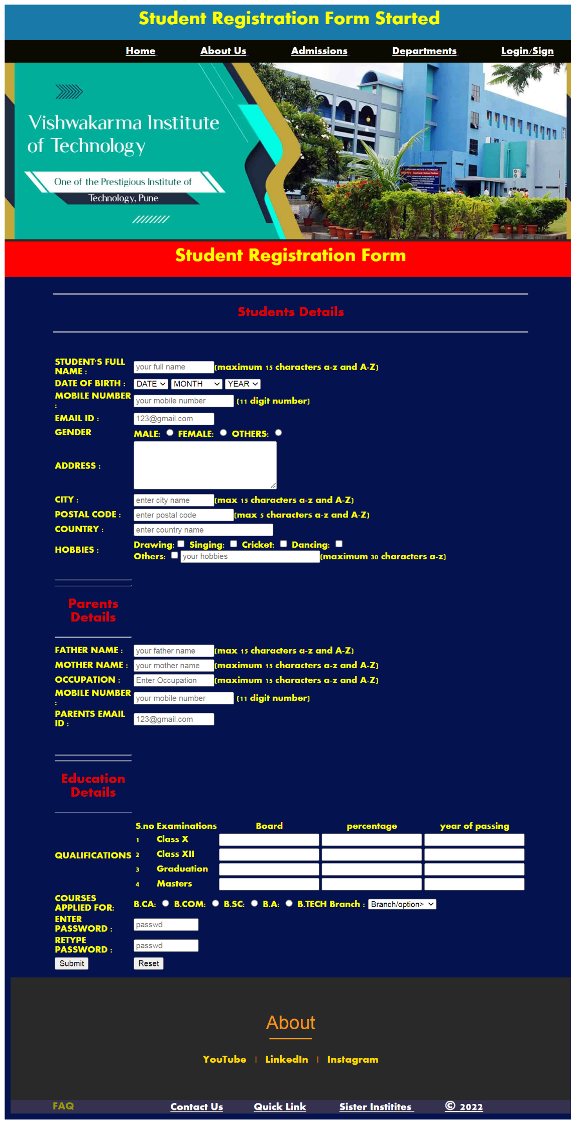**Output:**

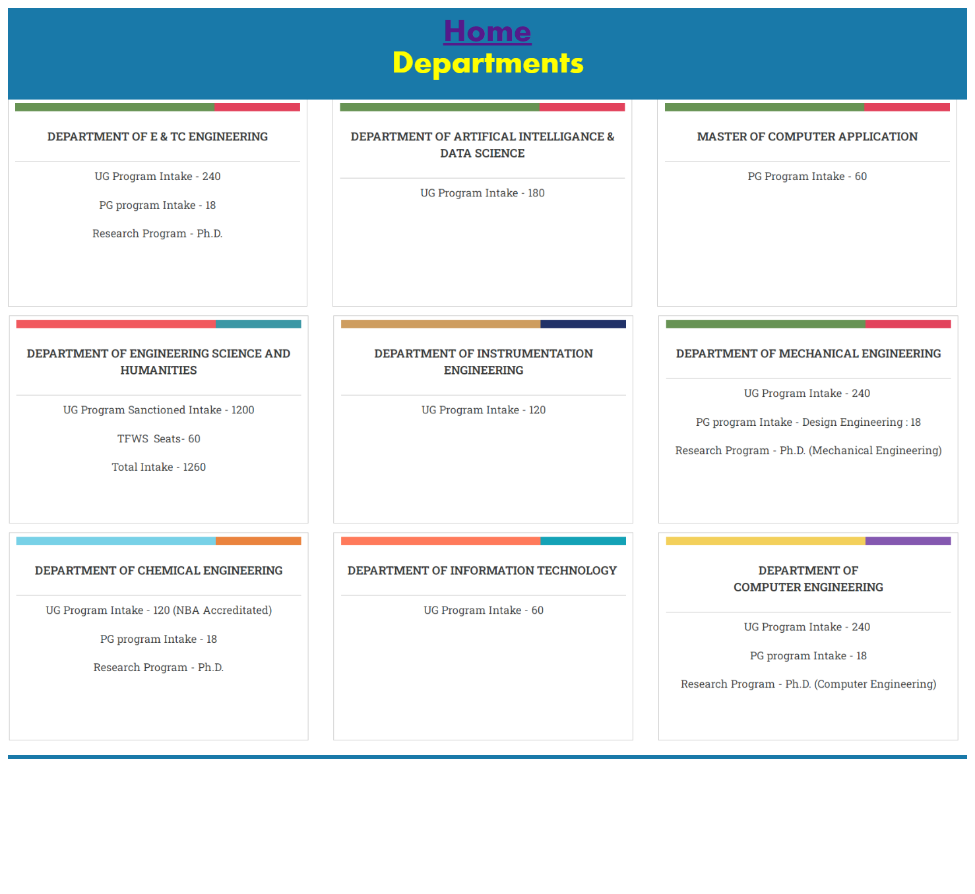

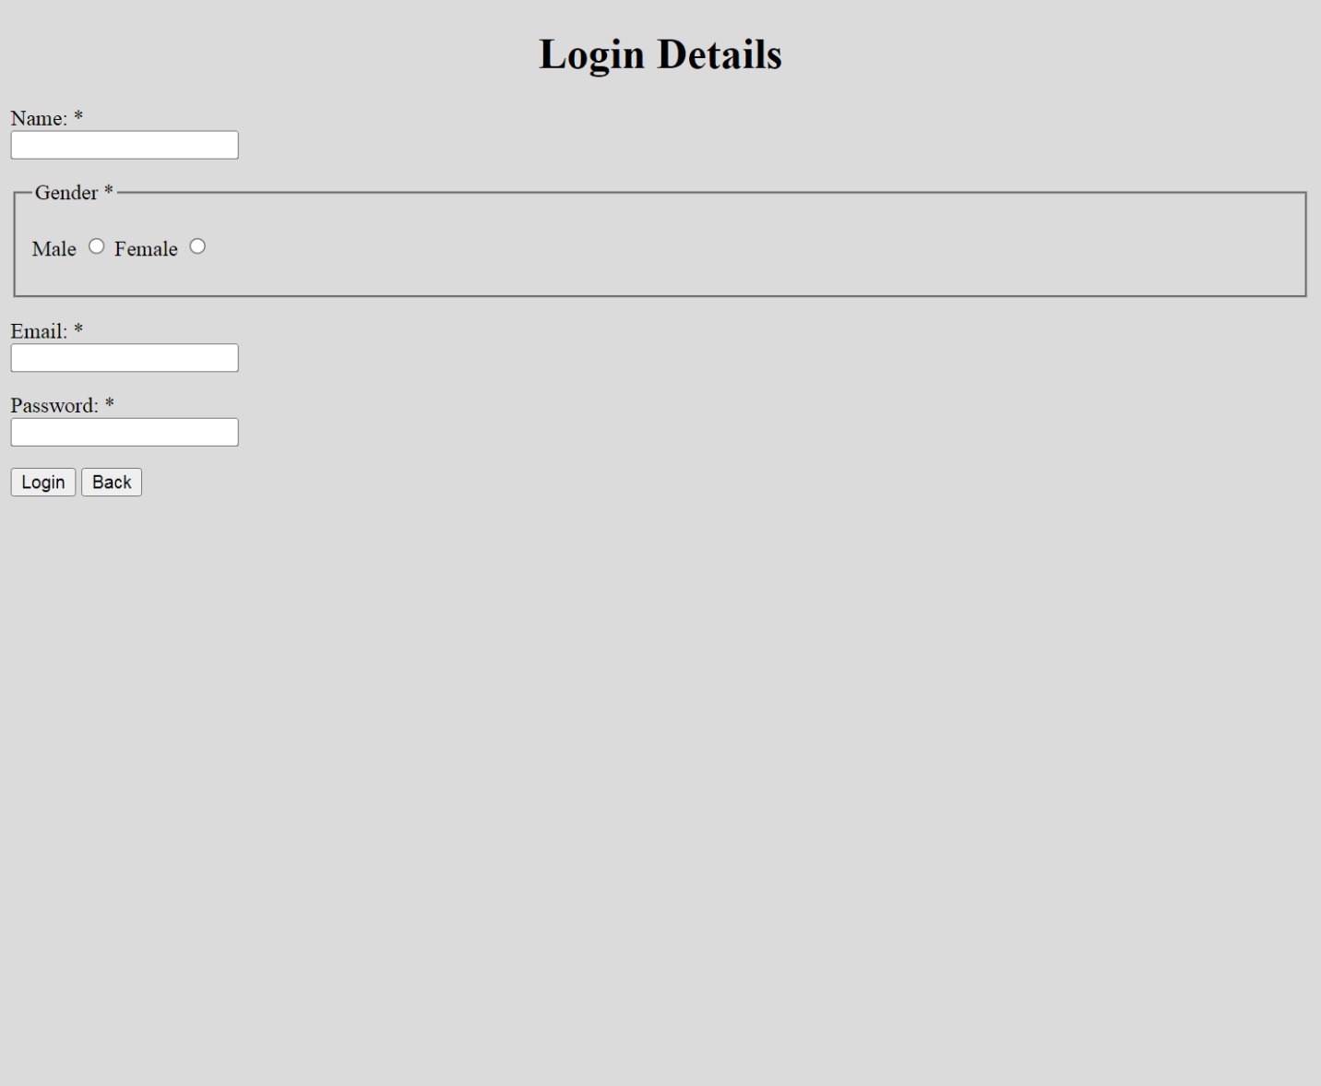

**\*\*\*\*\*\*\*\*\*\*\*\*\*\*\*\*\*\*\*\*\*\*\*\*\*\*\*\*\*END\*\*\*\*\*\*\*\*\*\*\*\*\*\*\*\*\*\*\*\*\*\*\*\*\*\*\***